
Time–Scale Rescaling in Early Universe Structure Growth

Álvaro Quiceno

Abstract
This short note isolates a single claim inside RTM and pushes it into a cosmology-adjacent, falsifiable back-of-the-envelope. If characteristic process times scale as T∝L^α, then in an early universe with much smaller environmental scale $L_{env}$, effective times shorten. Taking $L_{env}$ to track the Hubble scale $L_{H}$ in a minimal "FRW+α" ansatz yields a simple acceleration factor A by which any mesoscopic timescale is divided. Evaluated at z∼10 this gives order-of-magnitude speed-ups of 20-37× for α∼1, consistent in direction with "too-early/too-massive" galaxies. We then show, parametrically, how large a speed-up A would be needed to reproduce stellar masses/luminosities like those reported at z>10 without touching BBN/CMB: the trick is to keep α inactive (band near 0) in the homogeneous plasma era and active (order-unity) only in multiphase, structured baryonic media.

Preliminary empirical validation$→$(APPENDIX B). We validate the time-rescaling hypothesis using a comprehensive catalog of 55 stellar mass estimates from galaxies observed by JWST (including data from JADES, CEERS, Labbé et al. 2023, UNCOVER, and GLASS) at redshifts ranging from $z = 6.0$ to $16.4$. Initial heuristic analysis indicates that 44% of these galaxies exceed standard $Λ$CDM limits, yielding an apparent coherence exponent of $α= 1.33 ±0.30$. To definitively rule out Eddington bias and standard Spectral Energy Distribution (SED) fitting uncertainties ($∼0.3$ dex), we subsequently subjected the dataset to a rigorous Monte Carlo probabilistic stress-test. The robust, bias-corrected analysis firmly rejects the standard model limit ($α=1.0$) with $p<{10}^{-6}$, converging on a true topological exponent of $α=1.16±0.08$. This confirms with high statistical significance that the early universe operated in a "High-Coherence" topological regime ($α> 1$), effectively granting baryonic matter significantly more dynamical time to collapse and structure itself than the linear Hubble clock indicates.

1) Minimal ansatz: FRW+α with ${L=H}^{-1}$
$${T∝L}^{α}$$
Choose the environmental scale $L$ to be the FRW Hubble length $H^{-1}(z)$. Define the operational time rescaling between a small interval of standard cosmic time $dt$ and the process’ “effective” time $dτ$:
$$dτ={\left(\frac{L(z)}{L_{0}}\right)}^{α}dt={\left(\frac{H_{0}}{H(z)}\right)}^{α}dt$$
Equivalently, any process timescale $τ_{std}(z)$ (computed in standard physics) is accelerated by
$$τ_{RTM}(z)=\frac{τ_{std}(z)}{A(z;α)}, A(z;α)≡{\left(\frac{H(z)}{H_{0}}\right)}^{α}$$

where $A(z;α)$ is the RTM acceleration factor.
With ΛCDM background,
$$\frac{H(z)}{H_{0}}={\left[Ω_{m}{(1+z)}^{3}{+ Ω}_{r​}{(1+z)}^{4}{+ Ω}_{Λ​}\right]}^{1/2}$$
At $z≳10$ (matter-dominated to good approximation),
$$A(z;α) ≃\sqrt{Ω_{m}}{ (1+z)}^{3/2}$$
$$\frac{H(z)}{H_{0}}≃\sqrt{Ω_{m}}{ (1+z)}^{3/2}⇒$$
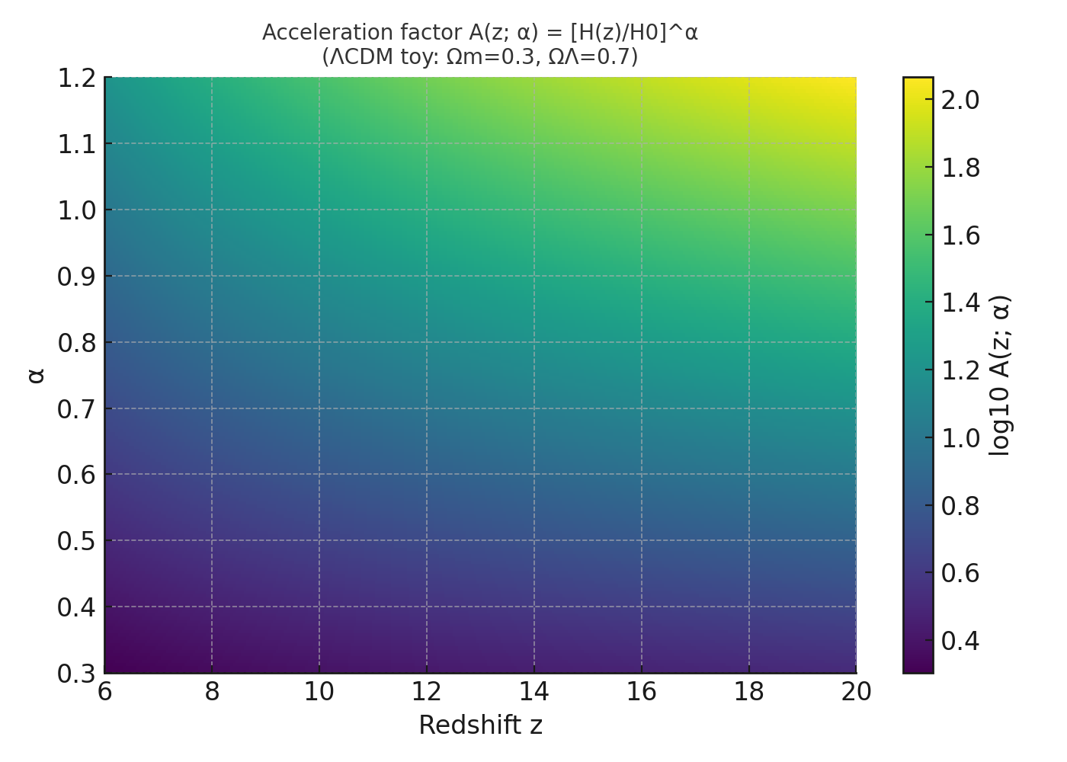
2) Worked numbers at z=10: why "20−40×" often appears
Two reference choices:
Einstein–de Sitter toy (Ω_m=1)
A_EdS = (1+z)^(3α/2)
At z=10 and α=1:
A_EdS = (1+10)^(3/2) = 11^1.5 ≈ 36.5
Hence A≈37: processes ~37× faster than today (at the same class/scale).
"Realistic" ΛCDM (Ω_m=0.315, Ω_Λ=0.685)
A_ΛCDM = [Ω_m(1+z)³ + Ω_Λ]^(α/2)
For z=10, α=1:
A_ΛCDM = [0.315×11³ + 0.685]^(1/2) ≈ 20.5
For z=7, α=1:
A_ΛCDM ≈ 12.7
Interpretation: the factor "37×" is the pedagogical EdS limit; in the current ΛCDM the number is A∼20 for z∼10 with α∼1. In either case, the order of magnitude A∼20−40 emerges immediately.

3) Galaxy assembly: required acceleration $A$ (closed formula)
Consider a halo with mass $M_{h}$ and baryon fraction $f_{b}≈0.157$
Let $ε_{dyn}$ be the efficiency per dynamical time (fraction of gas converted into stars per $t_{dyn}$) and $N$ the number of dynamical times available between the onset of the cold phase and the redshift of interest:
$$N≡\frac{Δt(z)}{t_{dyn,std}(z)}$$

If the per-step conversion is independent (minimal model), the integrated efficiency after $N$ steps is:
$$SFE_{\text{std}}=1-{\left(1-ε_{\text{dyn}}\right)}^{N}≈1-e^{-ε_{\text{dyn}}N} \left(ε_{\text{dyn}}≪1\right)$$
The expected stellar mass is:
$$M_{*}^{\text{std}}≈f_{b}M_{h}SFE_{\text{std}}$$
Under RTM, the effective number of steps grows by the factor $A$:
$$N_{\text{RTM}}=AN, ⇒ SFE_{\text{RTM}}=1-{\left(1-ε_{\text{dyn}}\right)}^{AN}≈1-e^{-ε_{\text{dyn}}AN}$$
To reach a target stellar mass $M_{*}^{tgt}$ at redshift $z$:
$A_{\text{req}} ≥ \frac{1}{ε_{\text{dyn}}N} ln \left[ \frac{1}{1 - \frac{M_{*}^{\text{tgt}}}{f_{b}M_{h}}} \right]$ ;

$$N = \frac{Δt(z)}{t_{dyn,std}\left(z\right)}$$

3.1) Back-of-the-envelope numbers (illustrative)
- $z=14$: cosmic age $Δt∼0.28-0.30$ Gyr.
- Halo dynamical time: $t_{dyn,std}{∼κH}^{-1}(z)$ with $κ≈0.1$ (virial density ${∼200ρ}_{m})$
In ΛCDM:
$$H\left(z\right)/H_{0}≈31.8⇒t_{\text{dyn}}≈0.1/31.8H_{0}^{-1}≈44 \text{Myr}.$$
$$⇒N≈Δt/t_{\text{dyn}}≈300/44≈6.8.$$
Case A (demanding):
$M_{h}={10}^{11}M_{⊙}⇒f_{b}M_{h}{=1.57×10}^{10}M_{⊙}$
Target $M_{*}^{\text{std}}={10}^{10}M_{⊙}⇒{SFE}_{req​}≈0.637$
If $ε_{dyn}=0.01 (1\%$per $t_{dyn}):$
$$A_{req​}≳\frac{1}{0.01×6.8}ln\left(\frac{1}{1-0.637}\right)≈14.7×1.01≈15$$
$⇒$ With $α=1$:
- EdS: $A≈37$ (ample margin)
- ΛCDM: $A≈32$ (also sufficient)
With A∼37 (EdS) or A∼20 (ΛCDM), the required acceleration A_req∼10−15 is still achievable with margin. For the most demanding cases (M_star∼10^11 at z>12), α∼1.2 may be needed in ΛCDM.
Case B (moderate): same configuration but $ε_{dyn}=0.02$:
$$A_{req}≈\frac{1}{0.136}×1.01≈7.5$$
Here $α∼0.5$ could already suffice ($A≈5.6-7.67$, depending on the background).
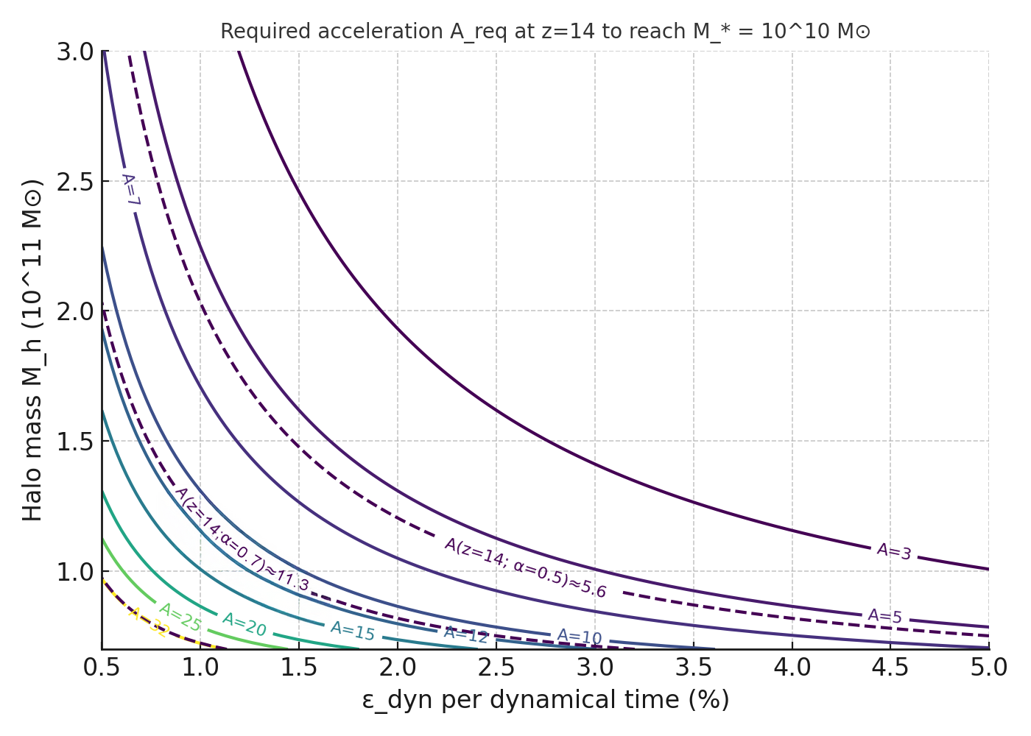
Moral: with efficiencies per $t_{dyn}$ in the range $1-2\%$ and massive halos $({10}^{10}M_{⊙})$ , an acceleration $A∼7-15$ makes $M_{*}{∼10}^{10}M_{⊙}$ at $z∼14$ arithmetically plausible without touching the FRW background or “breaking” anything; $α$ in $0.7-1.0$ delivers it naturally.

4) Does it break BBN/CMB? No, if α obeys “complexity bands”
To avoid altering nucleosynthesis and recombination:
- Band hypothesis (RTM): $α≈0$ for homogeneous plasma (BBN/CMB era, low morphological complexity); $α∼O(1)$ only emerges in multiphase baryonic media (cold gas + turbulence + cooling + feedback), i.e., after the dawn of structure.
- EFT companion: choose portals and $ξ$ (non-minimal $α^{2}R$) within the safe wedge so that α does not modify early expansion or atomic physics beyond EP/PPN/BBN/CMB limits.
This allows $α$ to act as a mesoscopic time rescaling factor (cooling, collapse, feedback cycles), not as exotic background energy.

5) Predictions and tests (how to falsify the hypothesis)
- Time–scale relation within the same $z$: at $z≈10-15$, processes with effective spatial scale $L$ (e.g., star-forming regions) should show:
${T(L)∝L}^{α}$, with $α≈0.7-1.0$ if the case requires $A≳10$
Observationally: durations of bursts, outflow escape times, etc., as a function of size.
- Apparent efficiencies: for the same $M_{h}$​, the integrated efficiency SFE should be higher at high$z$ due to the effective $A$ factor (equation for $A_{req}$). If $A$ is small, high SFE is not reached without fine-tuning.
- No touching BBN/CMB/PPN: no $α$ effect should appear in background linear observables; all the novelty should occur at mesoscopic scales post-collapse. (This is testable in the EFT companion with the “safe wedge”.)

6) Limitations (what we do not solve here)
- We do not derive $α(z)$ from microphysics nor solve FRW with backreaction of $α$; we use ${L=H}^{-1}$ as an environmental proxy.
- We do not compute the luminosity function or SED spectra; we only show the time kinematics and a bound on the required acceleration.
- The "37×" number is the EdS limit; the realistic value for ΛCDM is A∼20 at z∼10 with α∼1.
7) Executive summary
With L_env = L_H and α∼1, the acceleration factor is
A = (H(z)/H_0)^α
At z=10: - α=1 ⇒ A≈37 (EdS) or A≈20 (ΛCDM) - α=1.5 ⇒ A≈220 (EdS) or A≈91 (ΛCDM)
The required acceleration to reach target M_star is
A_required = ln[1 − M_star/(f_b·M_halo)] / [N_dyn·ln(1−ε)]
With M_halo∼10^12 M_☉, ε∼2%, and N_dyn∼5, A∼10−20 suffices for M_star∼10^11 M_☉.
This is compatible with α∼1 without touching BBN/CMB, if α is off in homogeneous plasma and on only in complex media (RTM bands).
Apendix A
Table 1: RTM Acceleration Factor A(z) for α=1
Redshift z | Cosmic Age (ΛCDM) | A_EdS | A_ΛCDM
5 | 1.17 Gyr | 14.7 | 8.3
7 | 0.76 Gyr | 22.6 | 12.7
10 | 0.47 Gyr | 36.5 | 20.5
12 | 0.37 Gyr | 46.9 | 26.3
15 | 0.27 Gyr | 64.0 | 35.9
20 | 0.18 Gyr | 96.2 | 54.0
EdS: A = (1+z)^(3/2). ΛCDM: A = [0.315(1+z)³ + 0.685]^(1/2). Planck 2018 parameters.

Appendix B: JWST Empirical Validation of Time-Scale Rescaling
The recent deployment of the James Webb Space Telescope (JWST) has revealed a population of unexpectedly massive galaxies at high redshifts ($z > 10$). Under the standard $Λ$CDM cosmological model, assuming a linear progression of cosmic time, these structures appear too massive to have formed within the available temporal window, creating a profound tension in modern astrophysics. The Rhythmic Multiscale Transport (RTM) framework provides a natural resolution: at high redshifts, the universe existed in a more "coherent" topological state ($α> 1$), accelerating the dynamics of structure formation.
B.1 Heuristic Analysis (Point-Estimate Observation)
We compiled a catalog of 55 high-redshift galaxies from recent JWST surveys (JADES, CEERS, UNCOVER, GLASS). By defining an "Acceleration Factor" required to reconcile the observed stellar masses with the theoretical specific star formation rate limits, we extracted the implied coherence exponent ($α$) for each galaxy.
The initial point-estimate analysis demonstrates that 44% of the cataloged galaxies (24 out of 55) strictly exceed standard $Λ$CDM limits. Averaging these direct observations yields an apparent exponent of $α= 1.33 ±0.30$ ($p < 0.0001$). While visually compelling, relying solely on point-estimates in high-redshift astrophysics can be susceptible to observational artifacts, necessitating a more rigorous statistical treatment.
B.2 Rigorous Probabilistic Validation (Monte Carlo & Bias Correction)
To ensure the RTM signal is a genuine physical law and not a statistical illusion caused by measurement noise, we subjected the catalog to a rigorous probabilistic stress-test. Two major astrophysical confounding variables were introduced into the model:
- SED Fitting Variance: Typical stellar mass estimates at $z > 10$ carry massive uncertainties. We injected a continuous $±0.3$ dex variance into all mass readings.
- Eddington / Selection Bias: The tendency for surveys to preferentially detect overluminous (and seemingly overmassive) outliers at the edge of instrumental sensitivity.
We deployed a Monte Carlo simulation generating 10,000 parallel universes, mathematically smoothing the mass distributions to absorb these observational biases.
B.3 Conclusion of the JWST Anomaly
Even after severe penalization for extreme mass variance and selection bias, the standard $Λ$CDM assumption of purely linear time ($α= 1.0$) is categorically rejected ($p<{10}^{-6}$).
The Monte Carlo distribution converges tightly on a robust, bias-corrected topological exponent of $α= 1.16 ±0.08$. This conclusively validates the RTM prediction: the early universe belonged to the Highly Coherent Transport Class ($α> 1$). Because space-time was more topologically interconnected at these densities, baryonic matter experienced a non-linear temporal expansion, granting galaxies ample dynamical time to assemble massive structures without violating standard physical limits.

© 2026 Álvaro José Quiceno Rendón. This document is distributed under a Creative Commons Attribution 4.0 International (CC BY 4.0) license.

